|  |
| --- |
| Name: Mr. Ranul Pasan Ladduwahetty |
| Student Reference Number: 10673986 |



|  |  |  |
| --- | --- | --- |
| Module Code: ISAD254SL - 19/AU/M | Module Name: ISAD254SL Human Computer Interaction (19/AU/M) | |
| Coursework Title: Group Assignment (ISAD254SL/C1/W1) | | |
| Deadline Date: Monday, 18 May 2020 | | Member of staff responsible for coursework: Dr. Shirley Atkinson and Ms. Pavithra Subashini |
| Programme: BSc (Hons) Software Engineering (4872) | | |
| Please note that University Academic Regulations are available under Rules and Regulations on the University website [www.plymouth.ac.uk/studenthandbook](http://www.plymouth.ac.uk/studenthandbook). | | |
| Group work: please list all names of all participants formally associated with this work and state whether the work was undertaken alone or as part of a team. Please note you may be required to identify individual responsibility for component parts.  Mr. R.P. Ladduwahetty  Mr. H.V.L. Hasanka  Mr. K.M.A.R.P Chamarasinghe  Mr. W.A.D.N.N. Wijesuriya  Mr. M.I.C. Bandara  ***We confirm that we have read and understood the Plymouth University regulations relating to Assessment Offences and that we are aware of the possible penalties for any breach of these regulations. We confirm that this is the independent work of the group.***  Signed on behalf of the group: Mr. R. P. Ladduwahetty | | |
| Individual assignment: ***I confirm that I have read and understood the Plymouth University regulations relating to Assessment Offences and that I am aware of the possible penalties for any breach of these regulations. I confirm that this is my own independent work.***  Signed : | | |
| Use of translation software: failure to declare that translation software or a similar writing aid has been used will be treated as an assessment offence.  I *have used/not used translation software.  If used, please state name of software………………………………………………………………… | | |
| **Overall mark _____% Assessors Initials ______ Date_________** | | |



**ISAD254SL**

**Human Computer**

**Interaction**

**Coursework**

**2020**

Group Details

Group No: 1

Group Name: TEAM RPLS

GitHub: <https://github.com/LRANUL/UOP_SE_Y2S2-ISAD254SL_HUMAN_COMPUTER_INTERACTION>

Project Management: <https://rpls.atlassian.net/wiki/spaces/2Y/overview>

Technologies **–** HTML, CSS, Bootstrap Framework and JS

**Group Members**

|  |  |  |  |
| --- | --- | --- | --- |
| NSBM ID | Plymouth ID | Student Name | Degree Program |
| **10026394** | **10673986** | **Mr. R.P. Ladduwahetty (Team Head)** | **SE** |
| 10026404 | 10673969 | Mr.H.V.L. Hasanka (Deputy Head) | SE |
| 10022546 | 10673943 | Mr. K.M.R.P. CHAMARASINGHE | SE |
| 10012039 | 10673936 | Mr. M.I.C BANDARA | SE |
| 10022548 | 10674049 | Mr. W.A.D.N.N. WIJESURIYA | SE |

*SE: BSc (Hons) Software Engineering (4872)

Table of Contents

1 Introduction 1

1.1 Introduction to Project 1

1.2 Problem Statement 1

2 PACT Analysis 2

2.1 PEOPLE 2

2.1.1 People Analysis by Mr. R.P. Ladduwahetty 2

2.1.2 People Analysis by Mr. H.V.L. Hasanka 2

2.1.3 People Analysis by Mr. M.I.C BANDARA 2

2.1.4 People Analysis by Mr. W.A.D.N.N. WIJESURIYA 2

2.2 ACTIVITIES 3

2.2.1 Activities Analysis by Mr. R.P. Ladduwahetty 3

2.2.2 Activities Analysis by Mr. H.V.L. Hasanka 3

2.2.3 Activities Analysis by Mr. M.I.C BANDARA 3

2.2.4 Activities Analysis by Mr. W.A.D.N.N. WIJESURIYA 3

2.3 CONTEXT 4

2.3.1 CONTEXT Analysis by Mr. R.P. Ladduwahetty 4

2.3.2 CONTEXT Analysis by Mr. H.V.L. Hasanka 4

2.3.3 CONTEXT Analysis by Mr. M.I.C BANDARA 4

2.3.4 CONTEXT Analysis by Mr. W.A.D.N.N. WIJESURIYA 4

2.4 TECHNOLOGIES 5

2.4.1 Technologies Analysis by Mr. R.P. Ladduwahetty 5

2.4.2 Technologies Analysis by Mr. H.V.L. Hasanka 5

2.4.3 Technologies Analysis by Mr. M.I.C BANDARA 5

2.4.4 Technologies Analysis by Mr. W.A.D.N.N. WIJESURIYA 5

3 User Profiles 6

3.1 User Profiles by Mr. R.P. Ladduwahetty 6

3.1.1 Outpatient 6

3.1.2 Parents/Children 6

3.1.3 Emergency Unit Patients 6

3.2 User Profiles by Mr. H.V.L. Hasanka 7

3.2.1 Nurses 7

3.2.2 Support Staff 7

3.3 User Profiles by Mr. W.A.D.N.N. WIJESURIYA 8

3.3.1 Elders 8

3.3.2 Inpatients 8

3.4 User Profiles by Mr. M.I.C BANDARA 9

4 Task Analysis Diagrams 10

5 Lo-Fidelity Prototypes 11

5.1 Lo-Fidelity Prototypes by Mr. R. P. Ladduwahetty 11

5.1.1 Welcome Page – English 11

5.1.2 Home Page 12

5.1.3 Healthy Lifestyle 13

5.1.4 Travelers Guide 14

5.1.5 NOTICES PAGE 15

5.1.6 Wellbeing Page 16

5.1.6.1 Wellbeing Page – Menu 16

5.1.6.2 Wellbeing Page – Addiction 17

5.1.6.3 Wellbeing Page – Bone 18

5.1.6.4 Wellbeing Page – Child 19

5.1.6.5 Wellbeing Page – Exercise 20

5.1.6.6 Wellbeing Page – Mental 21

5.1.6.7 Wellbeing Page – Oral 22

5.1.7 Home Page – Tamil 23

5.2 Lo-Fidelity Prototypes by Mr. H.V.L. Hasanka 24

5.2.1 Information Officers 24

5.2.2 Indigineous Med 24

5.2.3 Related Sites 24

5.2.4 Staff Access 24

5.2.4.1 Staff Access – Menu 24

5.2.4.2 Staff Access – Other CIRCULARS 24

5.2.4.3 Staff Access – Staff Notices 24

5.2.4.4 Staff Access – Admin Modal 24

5.2.4.5 Staff Access – SCHEDULE CALENDAR Modal 24

5.2.4.6 Staff Access – Staff Research Modal 24

5.2.4.7 Staff Access – Staff Web Systems Modal 24

5.2.4.8 Staff Access – Training modal 24

5.2.4.9 Staff Access – Download 24

5.3 Lo-Fidelity Prototypes by Mr. W.A.D.N.N. WIJESURIYA 25

5.3.1 Gallery Clinic 25

5.3.2 Health Bulletins 25

5.3.3About us 25

5.3.4 Hospitals 25

5.3.4.1 Hospitals – Menu 25

5.3.4.2 Hospitals – clinics 25

5.3.4.3 Hospitals – Common HOSPITALs 25

5.3.4.4 Hospitals – Clinic options 25

5.3.4.5 Hospitals – MISSION & Vision 25

5.3.4.6 Hospitals – PDHS 25

5.3.4.7 Hospitals – RDHS 25

5.3.4.8 Hospitals – Top OFFICIALs 25

5.3.4.9 Hospitals – Training Schools 25

5.4 Lo-Fidelity Prototypes by Mr. M.I.C BANDARA 26

5.4.1 Telephone 26

5.4.1.1 Telephone – Search 26

5.4.1.2 Telephone – Search Expanded 26

5.4.2 Contact 26

5.4.3 Home Page Sinhala 26

5.4.4 Publication 26

5.4.4.1 Publication – Menu 26

5.4.4.2 Publication – Library 26

5.4.4.3 Publication – Manuals 26

5.4.4.4 Publication – Services 26

5.4.4.5 Publication – Health 26

6 Hi-Fidelity Prototypes 27

6.1 Hi-Fidelity Prototypes by Mr. R. P. Ladduwahetty 27

6.1.1 Welcome Page – English 27

6.1.2 Home Page 28

6.1.3 Healthy Lifestyle 29

6.1.4 Travelers Guide 30

6.1.5 NOTICES PAGE 31

6.1.6 Wellbeing Page 32

6.1.6.1 Wellbeing Page – Menu 32

6.1.6.2 Wellbeing Page – Addiction 33

6.1.6.3 Wellbeing Page – Bone 34

6.1.6.4 Wellbeing Page – Child 35

6.1.6.5 Wellbeing Page – Exercise 36

6.1.6.6 Wellbeing Page – Mental 37

6.1.6.7 Wellbeing Page – Oral 38

6.1.7 Home Page – Tamil 39

6.2 Hi-Fidelity Prototypes by Mr. H.V.L. Hasanka 40

6.2.1 Information Officers 40

6.2.2 Indigineous Med 40

6.2.3 Related Sites 40

6.2.4 Staff Access 40

6.2.4.1 Staff Access – Menu 40

6.2.4.2 Staff Access – Other CIRCULARS 40

6.2.4.3 Staff Access – Staff Notices 40

6.2.4.4 Staff Access – Admin Modal 40

6.2.4.5 Staff Access – SCHEDULE CALENDAR Modal 40

6.2.4.6 Staff Access – Staff Research Modal 40

6.2.4.7 Staff Access – Staff Web Systems Modal 40

6.2.4.8 Staff Access – Training modal 40

6.2.4.9 Staff Access – Download 40

6.3 Hi-Fidelity Prototypes by Mr. W.A.D.N.N. WIJESURIYA 41

6.3.1 Gallery Clinic 41

6.3.2 Health Bulletins 41

6.3.3 About us 41

6.3.4 Hospitals 41

6.3.4.1 Hospitals – Menu 41

6.3.4.2 Hospitals – clinics 41

6.3.4.3 Hospitals – Common HOSPITALs 41

6.3.4.4 Hospitals – Clinic options 41

6.3.4.5 Hospitals – MISSION & Vision 41

6.3.4.6 Hospitals – PDHS 41

6.3.4.7 Hospitals – RDHS 41

6.3.4.8 Hospitals – Top OFFICIALs 41

6.3.4.9 Hospitals – Training Schools 41

6.4 Hi-Fidelity Prototypes by Mr. M.I.C BANDARA 42

6.4.1 Telephone 42

6.4.1.1 Telephone – Search 42

6.4.1.2 Telephone – Search Expanded 42

6.4.2 Contact 42

6.4.3 Home Page Sinhala 42

6.4.4 Publication 42

6.4.4.1 Publication – Menu 42

6.4.4.2 Publication – Library 42

6.4.4.3 Publication – Manuals 42

6.4.4.4 Publication – Services 42

6.4.4.5 Publication – Health 42

7 Design Principles and Justification 43

8 Prototype 44

8.1 Technical Specification 44

8.1 Screenshots of Design 44

9 Usability Evaluation 45

Conclusion 46

Workload 47

Bibliography 48

References 49

**List of Tables**

Table 1: Outpatient User Profile Table 6

Table 2: Parents/Children User Profile Table 6

Table 3: Emergency Patient User Profile Table 6

Table 4: Nurses User Profile Table 7

Table 5: Support Staff User Profile Table 7

Table 6: Elder User Profile Table 8

Table 7: Inpatients User Profile Table 8

**List of Figures**

Figure 1: Lo-fidelity prototype of Welcome Page 11

Figure 2: Lo-fidelity prototype of Home Page - English 12

Figure 3: : Lo-fidelity prototype of Lifestyle Page 13

Figure 4: Lo-fidelity prototype of Travelers Page 14

Figure 5: Lo-fidelity prototype of Notices Page 15

Figure 6: Lo-fidelity prototype of Wellbeing Page 16

Figure 7: Lo-fidelity prototype of Wellbeing - Addiction Page 17

Figure 8: Lo-fidelity prototype of Wellbeing - Bone Health Page 18

Figure 9: : Lo-fidelity prototype of Wellbeing - Child Health Page 19

Figure 10: Lo-fidelity prototype of Wellbeing - Exercise Page 20

Figure 11: Lo-fidelity prototype of Wellbeing - Mental Health Page 21

Figure 12: Lo-fidelity prototype of Wellbeing - Oral Health Page 22

Figure 13: Lo-fidelity prototype of Home Page - Tamil 23

Figure 14: Hi-fidelity prototype of Welcome Page 27

Figure 15: Hi-fidelity prototype of Home Page - English 28

Figure 16: Hi-fidelity prototype of Lifestyle Page 29

Figure 17: Hi-fidelity prototype of Travelers Page 30

Figure 18: Hi-fidelity prototype of Notices Page 31

Figure 19: Hi-fidelity prototype of Wellbeing Page 32

Figure 20: Hi-fidelity prototype of Wellbeing - Addiction Page 33

Figure 21: Hi-fidelity prototype of Wellbeing - Bone Health Page 34

Figure 22: Hi-fidelity prototype of Wellbeing - Child Health Page 35

Figure 23: Hi-fidelity prototype of Wellbeing - Exercise Page 36

Figure 24: Hi-fidelity prototype of Wellbeing - Mental Health Page 37

Figure 25: Hi-fidelity prototype of Wellbeing - Oral Health Page 38

Figure 26: Hi-fidelity prototype of Home Page- Tamil 39

# 1 Introduction

## Introduction to Project

## Problem Statement

# 2 PACT Analysis

## 2.1 PEOPLE

### 2.1.1 People Analysis by Mr. R.P. Ladduwahetty

* The majority of the audience for the website will be general public of Sri Lanka, site will provide helpful information for tourists who may look for health care. Website has a separate area for medical staff to communicate privately.

### 2.1.2 People Analysis by Mr. H.V.L. Hasanka

* The users of this government health website would be mostly the web developers and web administrators that interact with the health sector and the public society. There are two main sections in this website, one section for the general public to view the content and the other for the staff to view particular content and manipulate assigned information.

### 2.1.3 People Analysis by Mr. M.I.C BANDARA

### 2.1.4 People Analysis by Mr. W.A.D.N.N. WIJESURIYA

* The main concern during the design stage is how can we make it easier and simpler for the people who use it and it was clearly said by Steve Krug (2006) mentions that the users shouldn’t have to think while browsing or using a system since the thinking makes the focus turn to how to use the system instead of actually using the system. So, it’s a point we must remember when developing. And I think we have achieved this objective because all the task users can do on the page could be done easily rather than going to multiple locations to do the function. And data could be easily found even from a list because they are in alphabetic order for the simplicity of the user.

## 2.2 ACTIVITIES

### 2.2.1 Activities Analysis by Mr. R.P. Ladduwahetty

* General website will be visited to seek health advice, find healthcare centers and contact support. Users will be able to check personal health advice, telephone directory, advice for travelers and emergency health alerts.
* High number daily access to the website will be from staff.
* Light colors such as light blue, yellow and white where used so the content is pleasing to eyes.
* Content is displayed simply and methodically.

### 2.2.2 Activities Analysis by Mr. H.V.L. Hasanka

* The general public will be notifying about the country’s latest health incidents and on how to engage their responsivities as citizens. This website has all the recent health situations well detailed where any person either local or foreign could understand as the content is provided in three native language, English, Sinhala and Tamil. People can also find the relevant information about the hospitals and organizations involved with the health sector from this website.
* The staff sector in this website is used to interact on their daily tasks which is categorized into sections. Like notices, access to web systems, admin access and others.

### 2.2.3 Activities Analysis by Mr. M.I.C BANDARA

### 2.2.4 Activities Analysis by Mr. W.A.D.N.N. WIJESURIYA

* The content on the website is displayed in manner that the user can find any details regarding the Sri Lanka health from hospital details to the location of each hospital. As mentioned by (Benyon, 2005). When clicking with the mouse a response time of less than 5 seconds is necessary for users not to feel frustrated. And this issue won’t be happening because our webpages are responsive in addition the data in web pages are reliable data which ensures that the users are not mislead by the data in our webpages.

## 2.3 CONTEXT

### 2.3.1 CONTEXT Analysis by Mr. R.P. Ladduwahetty

* Website is available is all three local languages so it’s easier for visitors to understand content.
* Website will be for checking health and safety advice, website will display an alert on every page if case of an emergency situation.

### 2.3.2 CONTEXT Analysis by Mr. H.V.L. Hasanka

* Throughout the website the content is placed where the different types of users can easily locate.
* The theme of the whole website is designed where uses with any age limit or condition has the comfort of using the website with ease. Like the usage of light blue and light colors throughout the website, usage of tabs, menus, multiple interconnecting webpages for visualizing different content and others.

### 2.3.3 CONTEXT Analysis by Mr. M.I.C BANDARA

### 2.3.4 CONTEXT Analysis by Mr. W.A.D.N.N. WIJESURIYA

* The website will display all the recent news details regarding the any health information and there won’t be any language restrictions because the website pages are available in all three main languages in Sri Lanka. In Addition, the people will be able to find the details of the nearest hospital or clinic and what their services are using the website. Also, they can look at the top official’s in the health department and as well as get to know more about the website on the website for instance what our goal is in the future.

## 2.4 TECHNOLOGIES

### 2.4.1 Technologies Analysis by Mr. R.P. Ladduwahetty

* Website will run on any device that has web browser capable of running JavaScript, content will get optimized depending on the size of device screen for optimal visibility.

### 2.4.2 Technologies Analysis by Mr. H.V.L. Hasanka

* Currently throughout the website, HTML, CSS, JavaScript and PHP is used. HTML is used to bring a stable structure to the website, CSS brings the styling of the website and JavaScript will handle the actions or the interactivity of the website. PHP is used to handle the different user portals and database connectivity. But currently these technologies are used to the standards of the previous version. Like the website responsive support for all types of device platforms like in mobile, it’s not compatible enough.
* This can be modernized by using the same technologies and the latest designing and modeling standards. Website responsiveness can be improved to relocate the content of the website depending of the type of device platform the user interacts with. By doing this, the website will be more interactive and responsive with the users on the purpose of being productivity and efficient.

### 2.4.3 Technologies Analysis by Mr. M.I.C BANDARA

### 2.4.4 Technologies Analysis by Mr. W.A.D.N.N. WIJESURIYA

* The website is accessible in any platform or device that is connected to the internet because the website is responsive to screen size for the betterment of the users. In addition, it contains visual effects when a user does a function for example clicking a button this is done to make the website look better and so that the website is dynamic and is interacting with the user for the functionality the user did rather than a static website.

# 3 User Profiles

## 3.1 User Profiles by Mr. R.P. Ladduwahetty

## 3.1.1 Outpatient

Table : Outpatient User Profile Table

|  |  |
| --- | --- |
| Outpatient | |
| Profession | Public and private workers, foreigners |
| Age | 35 – 80 years (Average: 57 years) |
| Gender | Male and Female |
| Education | Average visitors have General Education completed, some with bachelors and doctorate level. |
| Location | Anywhere from country, high number of outpatients go for Colombo for high quality treatment. |
| Status (Family) | Mostly adults Married with (1 or more Children) |
| Experience | 5 or more years of work experience |
| Disabilities | Below average visitors with disabilities |
| Summary | Usually comes to hospital for treatment of long-term diseases such as diabetes, high blood pressure, cancer, high cholesterol patients and people with Kidney transplants. |

### 3.1.2 Parents/Children

Table : Parents/Children User Profile Table

|  |  |
| --- | --- |
| Parents/Children | |
| Profession | Nursery Child or Working Parent |
| Age | 0-15 years (Children) and 20-35 Years (Parents) |
| Gender | 48% Male and 52% Female |
| Education | Little or no education to Bachelor |
| Location | Anywhere from the country |
| Status (Family) | Single (Children) and Married (Parents) |
| Experience | No work experience |
| Disabilities | *No known research locally.* |
| Summary | Usually comes to hospital for treatment of mandatory vaccines for newborn children and for recommended vaccines for cuts and other diseases such as DTaP vaccine and MMR vaccine. |

### 3.1.3 Emergency Unit Patients

Table : Emergency Patient User Profile Table

|  |  |
| --- | --- |
| Emergency Unit Patients | |
| Profession | People of profession |
| Age | 0-80 years (Average: 40 years) |
| Gender | 84% Male |
| Education | Average Education |
| Location | Western Province above average incidents |
| Status (Family) | Married and Single |
| Experience | People with and without work experience |
| Disabilities | Recently disabled, long term diseases, physical and mental limitations |
| Summary | Usually comes to hospital for treatment of fatal accidents and elderly diseases such as chronic obstructive pulmonary disease. |

## 3.2 User Profiles by Mr. H.V.L. Hasanka

### 3.2.1 Nurses

Table : Nurses User Profile Table

|  |  |
| --- | --- |
| Nurses | |
| Profession | Assistant Health Professionals |
| Age | 18 to 65 (Average: 30 to 35) |
| Gender | 91% Female / 9% Male |
| Education | Minimum requirement of higher education in medicine school |
| Location | Anywhere from the country |
| Status (Family) | Single or Married |
| Experience | Minimum 3 years in the medical sector |
| Disabilities | High amounts of stress in work environments. |
| Summary | Nurses helps the doctors with the basic tasks a patient would require. These tasks can be easy, but the demand of tasks may rise. So, they should have background knowledge on this sector. |

### 3.2.2 Support Staff

Table : Support Staff User Profile Table

|  |  |
| --- | --- |
| Support Staff | |
| Profession | Hospital Workers, Ward Clerks |
| Age | 18 to 65 |
| Gender | Male and female |
| Education | Average knowledge in the medical sector. Minimum high-school diploma and a training. |
| Location | Anywhere from the country |
| Status (Family) | Single or Married |
| Experience | Medical training. |
| Disabilities | Not Available |
| Summary | Support staff does the daily management operations in the hospital environments like in patient wards. They should have minor medical training as their main priority is management. |

## 3.3 User Profiles by Mr. W.A.D.N.N. WIJESURIYA

### 3.3.1 Elders

Table : Elder User Profile Table

|  |  |
| --- | --- |
| Elders | |
| Profession | Retired |
| Age | 65 or older |
| Gender | Male and female |
| Education | Average or very little education |
| Location | Anywhere from the country |
| Status (Family) | Married and most of them have children |
| Experience | Had worked in the past but now retired |
| Disabilities | Contain at least on disability due to age (Some of common disabilities are Hearing impairment, chronic heart failure, hip fractures etc.) |
| Summary | Elderly comes to the hospitals to do routine checkups on their health or it may because of a more serious issue such as heart attacks and stroke. |

### 3.3.2 Inpatients

Table : Inpatients User Profile Table

|  |  |
| --- | --- |
| Inpatients | |
| Profession | Public and private workers or foreigners |
| Age | 15 years and older |
| Gender | Male and female |
| Education | Most probably must have done higher education and has good knowledge or at least must have completed the basic level education. |
| Location | They may be from all over the country |
| Status (Family) | Married and single |
| Experience | People with and without work experience |
| Disabilities | People who are not disabled to people who got recently disabled. |
| Summary | Usually it’s because they have done a surgery and the patient’s health is still been monitored or it may be because the patient is not recovering with the current medication. |

## 3.4 User Profiles by Mr. M.I.C BANDARA

# 4 Task Analysis Diagrams

# 5 Lo-Fidelity Prototypes

## 5.1 Lo-Fidelity Prototypes by Mr. R. P. Ladduwahetty

### 5.1.1 Welcome Page – English

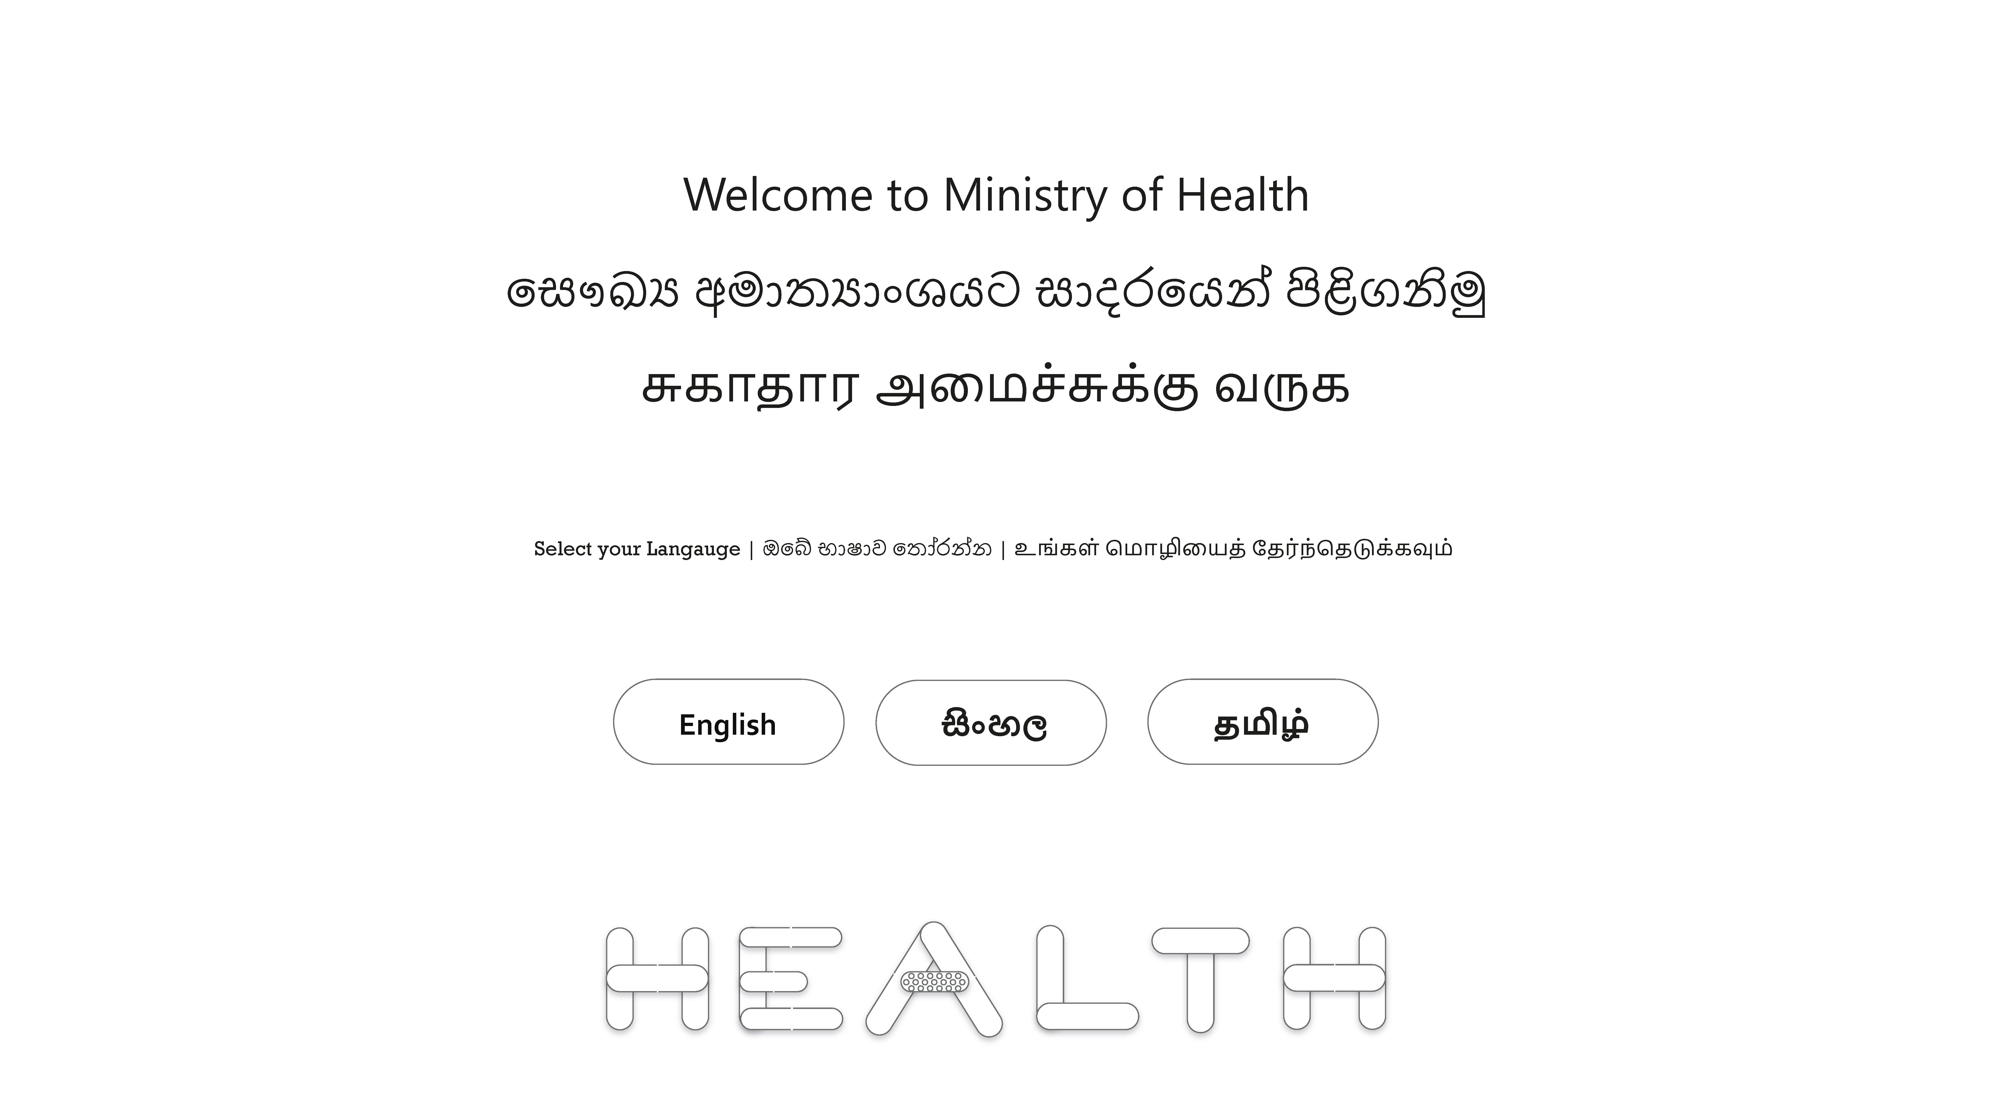

Figure : Lo-fidelity prototype of Welcome Page

### 5.1.2 Home Page



Figure : Lo-fidelity prototype of Home Page - English

### 5.1.3 Healthy Lifestyle



Figure : : Lo-fidelity prototype of Lifestyle Page

### 5.1.4 Travelers Guide



Figure : Lo-fidelity prototype of Travelers Page

### 5.1.5 NOTICES PAGE



Figure : Lo-fidelity prototype of Notices Page

### 5.1.6 Wellbeing Page

### 5.1.6.1 Wellbeing Page – Menu



Figure : Lo-fidelity prototype of Wellbeing Page

### 5.1.6.2 Wellbeing Page – Addiction



Figure : Lo-fidelity prototype of Wellbeing - Addiction Page

### 5.1.6.3 Wellbeing Page – Bone



Figure : Lo-fidelity prototype of Wellbeing - Bone Health Page

### 5.1.6.4 Wellbeing Page – Child



Figure : : Lo-fidelity prototype of Wellbeing - Child Health Page

### 5.1.6.5 Wellbeing Page – Exercise



Figure : Lo-fidelity prototype of Wellbeing - Exercise Page

### 5.1.6.6 Wellbeing Page – Mental



Figure : Lo-fidelity prototype of Wellbeing - Mental Health Page

### 5.1.6.7 Wellbeing Page – Oral



Figure : Lo-fidelity prototype of Wellbeing - Oral Health Page

### 5.1.7 Home Page – Tamil



Figure : Lo-fidelity prototype of Home Page - Tamil

## 5.2 Lo-Fidelity Prototypes by Mr. H.V.L. Hasanka

### 5.2.1 Information Officers

### 5.2.2 Indigineous Med

### 5.2.3 Related Sites

### 5.2.4 Staff Access

### 5.2.4.1 Staff Access – Menu

### 5.2.4.2 Staff Access – Other CIRCULARS

### 5.2.4.3 Staff Access – Staff Notices

### 5.2.4.4 Staff Access – Admin Modal

### 5.2.4.5 Staff Access – SCHEDULE CALENDAR Modal

### 5.2.4.6 Staff Access – Staff Research Modal

### 5.2.4.7 Staff Access – Staff Web Systems Modal

### 5.2.4.8 Staff Access – Training modal

### 5.2.4.9 Staff Access – Download

## 5.3 Lo-Fidelity Prototypes by Mr. W.A.D.N.N. WIJESURIYA

### 5.3.1 Gallery Clinic

### 5.3.2 Health Bulletins

### 5.3.3About us

### 5.3.4 Hospitals

### 5.3.4.1 Hospitals – Menu

### 5.3.4.2 Hospitals – clinics

### 5.3.4.3 Hospitals – Common HOSPITALs

### 5.3.4.4 Hospitals – Clinic options

### 5.3.4.5 Hospitals – MISSION & Vision

### 5.3.4.6 Hospitals – PDHS

### 5.3.4.7 Hospitals – RDHS

### 5.3.4.8 Hospitals – Top OFFICIALs

### 5.3.4.9 Hospitals – Training Schools

### 

## 5.4 Lo-Fidelity Prototypes by Mr. M.I.C BANDARA

### 5.4.1 Telephone

### 5.4.1.1 Telephone – Search

### 5.4.1.2 Telephone – Search Expanded

### 5.4.2 Contact

### 5.4.3 Home Page Sinhala

### 5.4.4 Publication

### 5.4.4.1 Publication – Menu

### 5.4.4.2 Publication – Library

### 5.4.4.3 Publication – Manuals

### 5.4.4.4 Publication – Services

### 5.4.4.5 Publication – Health

# 6 Hi-Fidelity Prototypes

## 6.1 Hi-Fidelity Prototypes by Mr. R. P. Ladduwahetty

### 6.1.1 Welcome Page – English

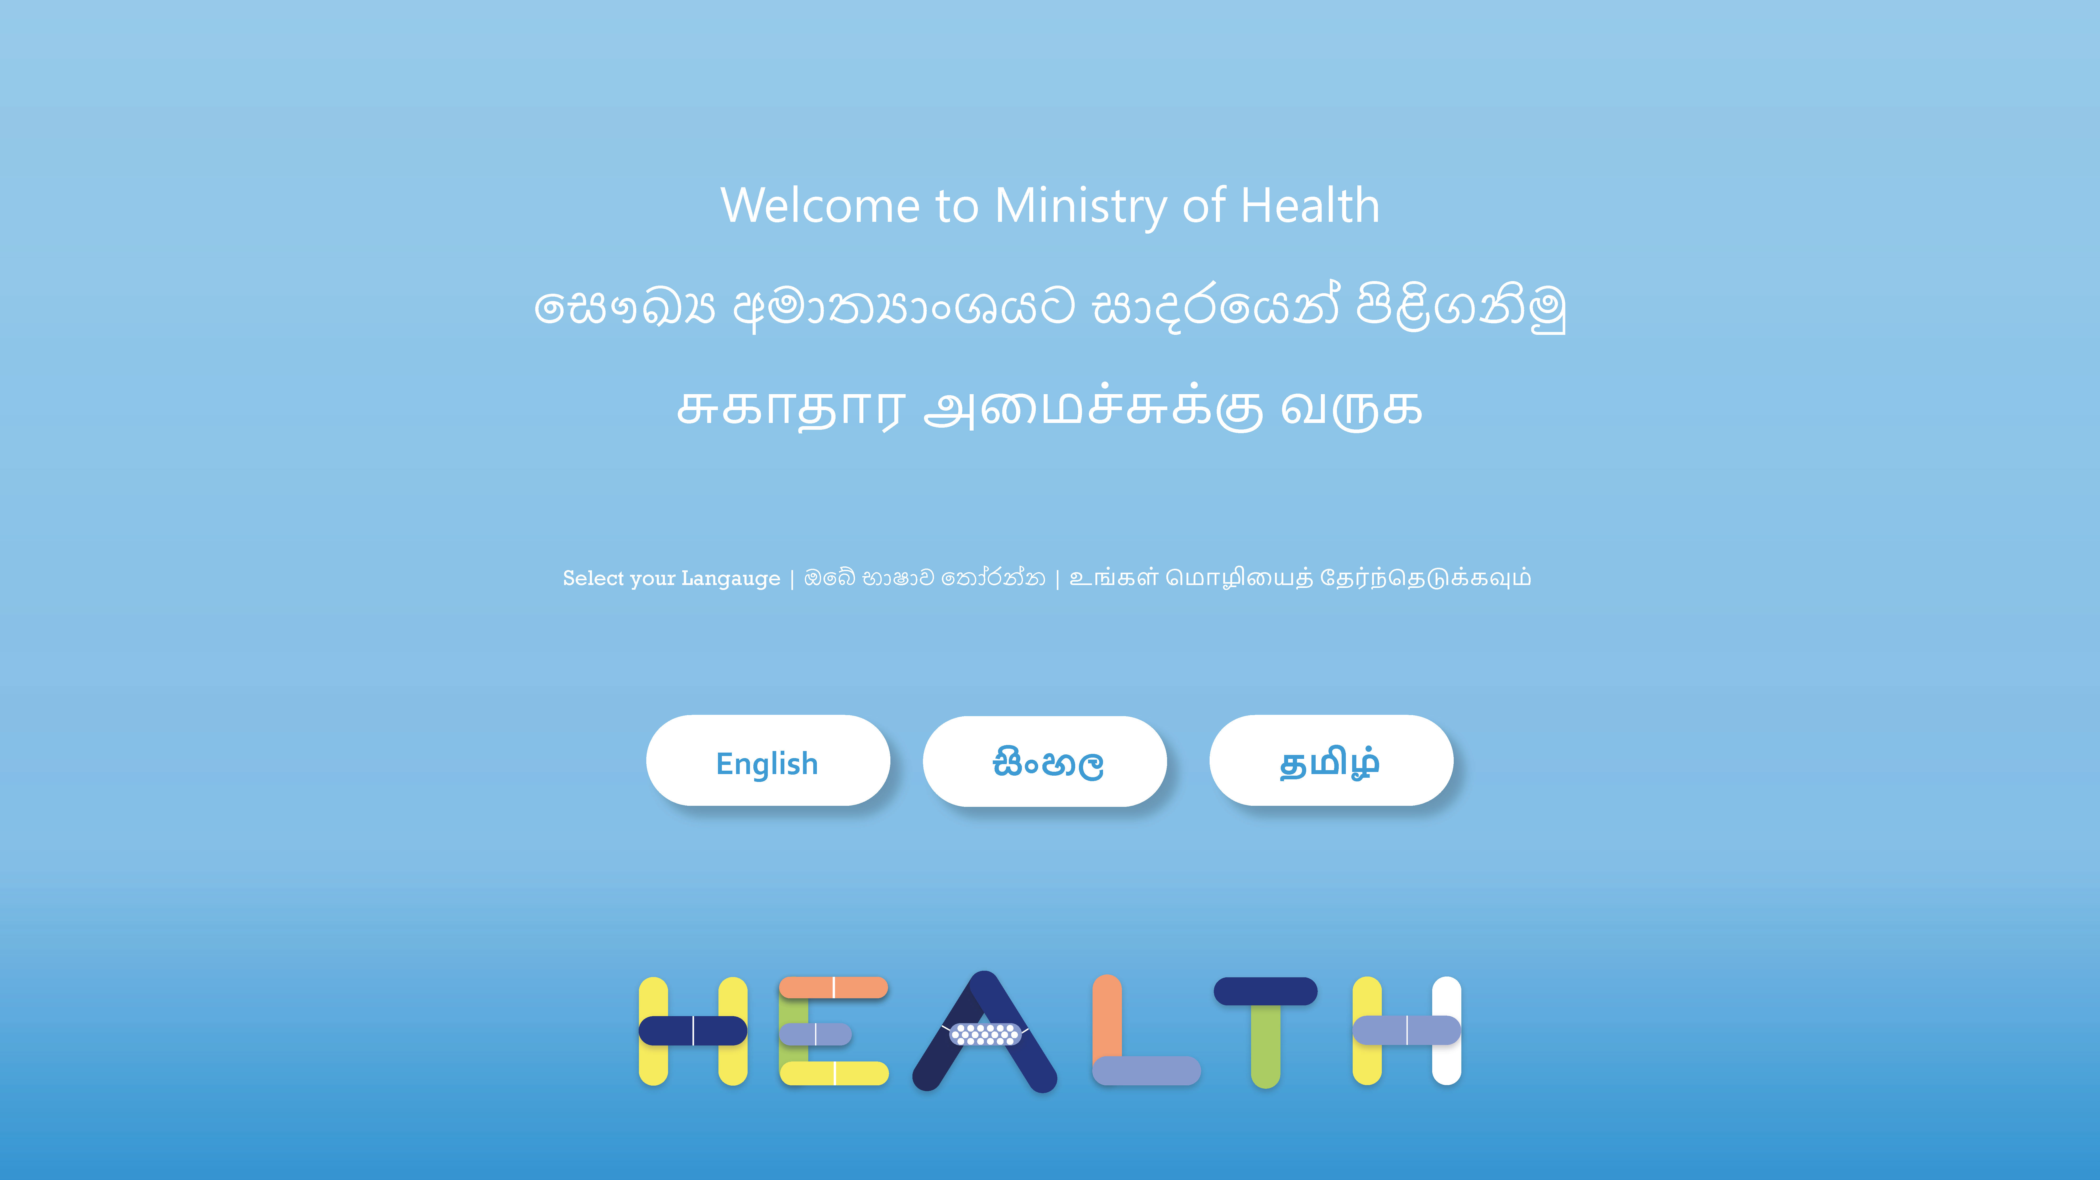

Figure : Hi-fidelity prototype of Welcome Page

### 6.1.2 Home Page



Figure : Hi-fidelity prototype of Home Page - English

### 6.1.3 Healthy Lifestyle



Figure : Hi-fidelity prototype of Lifestyle Page

### 6.1.4 Travelers Guide



Figure : Hi-fidelity prototype of Travelers Page

### 6.1.5 NOTICES PAGE



Figure : Hi-fidelity prototype of Notices Page

### 6.1.6 Wellbeing Page

### 6.1.6.1 Wellbeing Page – Menu



Figure : Hi-fidelity prototype of Wellbeing Page

### 6.1.6.2 Wellbeing Page – Addiction



Figure : Hi-fidelity prototype of Wellbeing - Addiction Page

### 6.1.6.3 Wellbeing Page – Bone



Figure : Hi-fidelity prototype of Wellbeing - Bone Health Page

### 6.1.6.4 Wellbeing Page – Child



Figure : Hi-fidelity prototype of Wellbeing - Child Health Page

### 6.1.6.5 Wellbeing Page – Exercise



Figure : Hi-fidelity prototype of Wellbeing - Exercise Page

### 6.1.6.6 Wellbeing Page – Mental



Figure : Hi-fidelity prototype of Wellbeing - Mental Health Page

### 6.1.6.7 Wellbeing Page – Oral



Figure : Hi-fidelity prototype of Wellbeing - Oral Health Page

### 6.1.7 Home Page – Tamil



Figure : Hi-fidelity prototype of Home Page- Tamil

## 6.2 Hi-Fidelity Prototypes by Mr. H.V.L. Hasanka

### 6.2.1 Information Officers

### 6.2.2 Indigineous Med

### 6.2.3 Related Sites

### 6.2.4 Staff Access

### 6.2.4.1 Staff Access – Menu

### 6.2.4.2 Staff Access – Other CIRCULARS

### 6.2.4.3 Staff Access – Staff Notices

### 6.2.4.4 Staff Access – Admin Modal

### 6.2.4.5 Staff Access – SCHEDULE CALENDAR Modal

### 6.2.4.6 Staff Access – Staff Research Modal

### 6.2.4.7 Staff Access – Staff Web Systems Modal

### 6.2.4.8 Staff Access – Training modal

### 6.2.4.9 Staff Access – Download

## 6.3 Hi-Fidelity Prototypes by Mr. W.A.D.N.N. WIJESURIYA

### 6.3.1 Gallery Clinic

### 6.3.2 Health Bulletins

### 6.3.3 About us

### 6.3.4 Hospitals

### 6.3.4.1 Hospitals – Menu

### 6.3.4.2 Hospitals – clinics

### 6.3.4.3 Hospitals – Common HOSPITALs

### 6.3.4.4 Hospitals – Clinic options

### 6.3.4.5 Hospitals – MISSION & Vision

### 6.3.4.6 Hospitals – PDHS

### 6.3.4.7 Hospitals – RDHS

### 6.3.4.8 Hospitals – Top OFFICIALs

### 6.3.4.9 Hospitals – Training Schools

### 

## 6.4 Hi-Fidelity Prototypes by Mr. M.I.C BANDARA

### 6.4.1 Telephone

### 6.4.1.1 Telephone – Search

### 6.4.1.2 Telephone – Search Expanded

### 6.4.2 Contact

### 6.4.3 Home Page Sinhala

### 6.4.4 Publication

### 6.4.4.1 Publication – Menu

### 6.4.4.2 Publication – Library

### 6.4.4.3 Publication – Manuals

### 6.4.4.4 Publication – Services

### 6.4.4.5 Publication – Health

# 7 Design Principles and Justification

# 8 Prototype

## 8.1 Technical Specification

## 8.1 Screenshots of Design

# 9 Usability Evaluation

# Conclusion

# Workload

|  |  |  |  |
| --- | --- | --- | --- |
| Student Name | Plymouth ID | Work Description* | Contribution as a % |
| Mr. R. P. Ladduwahetty | 10673986 | * Planning, Analysis and Literature review * PACT Analysis * User Profiles * Task Analysis diagrams * Lo-fidelity prototypes * Hi-fidelity prototypes * Design Principles and Justification * Prototype * Technical specifications * Usability Evaluation | 100% |
|  |  |  |  |
|  |  |  |  |
|  |  |  |  |
| Mr. K.M.R.P. CHAMARASINGHE | 10673943 | - | - |

*Each member signed and filled this workload form.

*For a contribution not filled in the matrix defines that the member was unable to support to the project due to the Covid-19 condition as the time of assessment

# Bibliography

# References